SIMATS ENGINEERING
ASSESSMENT TOOL 1

COURSE NAME: MLA03
COURSE CODE: Reinforcement learning for Environment and Agent
NAME: R. Rupa Sree
Register Number: 192472122

COURSE OUTCOME COVERED

CO2: Apply Dynamic Programming methods to solve reinforcement learning problems and derive optimal policies for decision-making tasks. (BL2, BL3)

Assessment Tool Weightage: 35%

Dr G. A. SENTHIL

QUESTIONS: 10 Total Marks: 50

Annexure A

Industry Problem Task

1. Explain how Reinforcement Learning can be applied to optimize delivery routes in a logistics system. Identify the possible states, actions, rewards, and policy. Discuss how continuous learning improves efficiency over time.
Ans: Reinforcement Learning for Delivery Route Optimization in Logistics
1.1 Objective
The objective is to develop an intelligent delivery routing system using Reinforcement Learning (RL) that learns the most efficient routes for delivering goods. The system aims to minimize travel time, fuel consumption, and delivery cost while maximizing on-time deliveries and customer satisfaction.
1.2 Why Reinforcement Learning is Suitable
Traditional routing algorithms use fixed rules and cannot easily adapt to dynamic traffic, weather, or road conditions. It enables an agent to learn from interactions with the environment and continuously improve its routing decisions. RL is suitable because it:
- Learns optimal routes through trial and error.
- Adapts to changing traffic conditions.
- Reduces delivery time.
- Minimizes fuel consumption.
- Improves operational efficiency over time.
1.3 Agent and Environment
Agent- The delivery vehicle (or routing software) acts as the RL agent.
Environment- The environment includes:
- Road network
- Traffic conditions
- Customer locations
- Weather conditions
- Delivery destinations
- Fuel availability
The agent observes the environment, selects the best route, receives rewards, and learns from experience.
1.4 State Space
The state represents the current situation of the delivery vehicle.
Examples include:
- Current vehicle location
- Remaining delivery locations
- Traffic congestion level and Fuel level
- Distance to destination
- Weather condition
- Time of day
- Vehicle load
Example State:
S = {Location = Warehouse, Traffic = Medium, Fuel = 70%, Packages = 5}
1.5 Action Space
The actions are the possible decisions the delivery agent can make.
Possible actions include:
- Move North
- Move South
- Move East
- Move West
- Select Highway
- Select Local Road
- Visit Next Customer
- Return to Warehouse
- Take Alternative Route
- Wait due to traffic

1.6 Reward Function
The reward function encourages efficient delivery.
Positive Rewards (+)
Action | Reward
Deliver package on time | +100
Select shortest route | +50
Save fuel | +30
Avoid traffic | +20
Complete all deliveries | +200
Negative Rewards (−)
Action | Penalty
Delay in delivery | -50
Heavy traffic route | -30
Extra fuel consumption | -20
Wrong route | -40
Missed delivery | -100

1.7 Policy- A policy defines how the agent selects actions in each state.
Policy Function is π(s) → a
where:
- π = Policy
- s = Current state
- a = Selected action
Example: If traffic is high, the policy selects an alternative road instead of the shortest road.

1.8 Learning Process- The RL agent learns by interacting with the logistics environment.
Step 1: Observe current state.
Step 2: Choose an action.
Step 3: Move to the next location.
Step 4: Receive reward or penalty.
Step 5: Update the policy.
Step 6: Repeat until all deliveries are completed.
- Exploration
The agent tries new routes to discover better delivery paths.
Example: Instead of taking the usual highway, it explores a newly opened road.
Advantages:
- Finds better routes.
- Learns traffic patterns.
- Improves knowledge of the environment.
- Exploitation
The agent uses the best-known route learned from previous experiences.
Advantages:
- Faster deliveries.
- Lower fuel cost.
- Higher customer satisfaction.

1.9 Continuous Learning
Continuous learning allows the agent to improve with every delivery.
The system learns:
- Peak traffic hours.
- Frequently congested roads.
- Customer delivery patterns.
- Fuel-efficient routes.
- Seasonal traffic changes.
As more delivery data is collected, routing decisions become increasingly efficient, reducing operational costs and improving delivery reliability.
1.10 Real-World Industry Example
Amazon uses AI and machine learning to optimize delivery routes by considering traffic, package priority, and customer locations. The system continuously updates routes to reduce delivery time and transportation costs.
1.11 RL Architecture
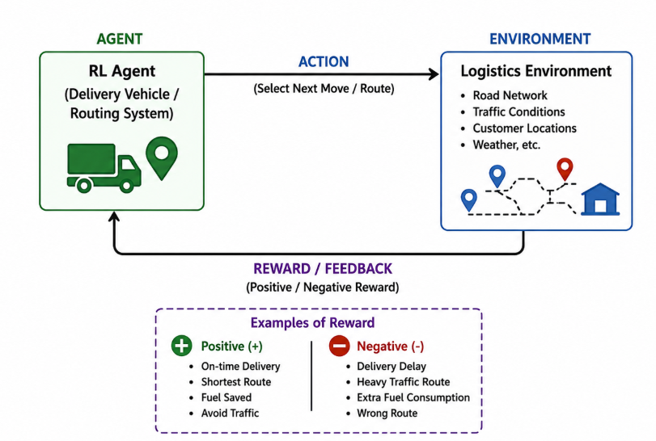
1.12 Advantages
- Reduces travel time.
- Lowers fuel consumption.
- Minimizes operational costs.
- Improves customer satisfaction.
- Adapts to real-time traffic.
- Optimizes delivery scheduling.
- Handles dynamic environments.
- Continuously improves performance.

1.13. Expected Outcome
By applying Reinforcement Learning, the logistics system learns the optimal delivery routes through continuous interaction with the environment. The agent minimizes delivery time, fuel usage, and operational costs while maximizing successful and on-time deliveries. Over time, the learned policy enables faster, more reliable, and more efficient logistics operations, improving overall business performance.
Conclusion
Reinforcement Learning provides an intelligent solution for delivery route optimization by enabling delivery vehicles to learn from experience and adapt to changing road conditions. Through well-defined states, actions, rewards, and policies, the RL agent continuously improves its decision-making process. This results in efficient route planning, reduced costs, timely deliveries, and enhanced customer satisfaction, making RL highly suitable for modern logistics systems.

2. Illustrate how Reinforcement Learning is used in a streaming platform for content recommendation. Discuss the impact of delayed rewards, user feedback, and changing preferences on learning performance.
Ans: Reinforcement Learning for Streaming Platform Recommendation
2.1 Objective
The objective is to develop an intelligent recommendation system using Reinforcement Learning (RL) that suggests movies, TV shows, or videos based on user interests. The system continuously learns from user interactions to improve recommendation accuracy and increase user engagement.
2.2 Why Reinforcement Learning is Suitable
Traditional recommendation systems rely on fixed user preferences and historical data. However, user interests change over time. Reinforcement Learning is suitable because it:
- Learns from user interactions.
- Adapts to changing user preferences.
- Maximizes user satisfaction.
- Increases watch time and engagement.
- Continuously improves recommendations through feedback.
2.3 Agent and Environment
Agent- The Recommendation Engine acts as the RL agent.
Environment- The environment consists of:
- Users
- Movies/TV shows
- User viewing history
- Ratings
- Search history
- Device type
- Time of day
The agent recommends content and receives feedback from user interactions.

2.4 State Space
The state represents the current profile and context of the user.
Examples include:
- User watch history
- Favorite genres
- Recently watched content
- Time of day
- Device (Mobile/TV/Laptop)
- Subscription type
- User age group
- Language preference
Example State
S = {Genre = Action, Time = Evening, Device = Mobile, Last Movie = Avengers}

2.5 Action Space
The actions are the recommendations made by the agent.
Possible actions:
- Recommend Action Movie
- Recommend Comedy Movie
- Recommend Thriller
- Recommend Web Series
- Recommend Documentary
- Recommend Recently Released Movie
- Recommend Trending Content
- Recommend Based on Watch History

2.6 Reward Function
The reward function evaluates the quality of recommendations.
Positive Rewards (+)
User Action | Reward
User watches recommended content | +100
User watches complete movie | +80
User gives 5-star rating | +60
User likes the content | +40
User subscribes | +150

Negative Rewards (−)
User Action | Penalty
User skips recommendation | -20
User exits application | -40
User dislikes recommendation | -50
User removes from watchlist | -30
User cancels subscription | -150

2.7 Policy
A policy determines which content should be recommended for each user state.
Policy Function: π(s) → a
where:
- π = Policy
- s = Current user state
- a = Recommended content
Example: If a user frequently watches science-fiction movies, the policy recommends more science-fiction content.

2.8 Learning Process
The recommendation agent follows these steps:
Step 1- Observe user profile.
Step 2- Recommend content.
Step 3- User watches or ignores recommendation.
Step 4- Receive reward or penalty.
Step 5- Update recommendation policy.
Step 6- Repeat for future recommendations.
- Exploration: The system recommends new or less popular content to discover hidden user interests.
Example: A user who watches only action movies may occasionally receive a documentary recommendation.
Advantages:
- Discovers new preferences.
- Prevents repetitive recommendations.
- Expands user interests.
- Exploitation
The system recommends content similar to what the user has previously enjoyed.
Advantages:
- Higher user satisfaction.
- Better recommendation accuracy.
- Increased watch time.

2.9 Delayed Rewards
In streaming platforms, rewards are often delayed because the system may not know immediately whether a recommendation was successful.
Example:
- A user watches the recommended movie two days later.
- The user completes an entire series over a week.
- The user renews their subscription after several successful recommendations.
2.10 User Feedback
User feedback helps the RL agent improve recommendations.
Examples of feedback:
- Likes
- Ratings
- Comments
Positive feedback increases the probability of recommending similar content in the future.

2.11. Changing User Preferences
User interests change over time due to:
- New movie releases
- Seasonal trends
- Mood changes
- Current events

2.12 Continuous Learning
Continuous learning enables the recommendation engine to:
- Learn from every user interaction.
- Improve recommendation accuracy.
- Adapt to changing interests.
- Reduce irrelevant suggestions.
- Increase user engagement and retention.
As more user data is collected, the system becomes increasingly personalized.

2.13 RL Architecture

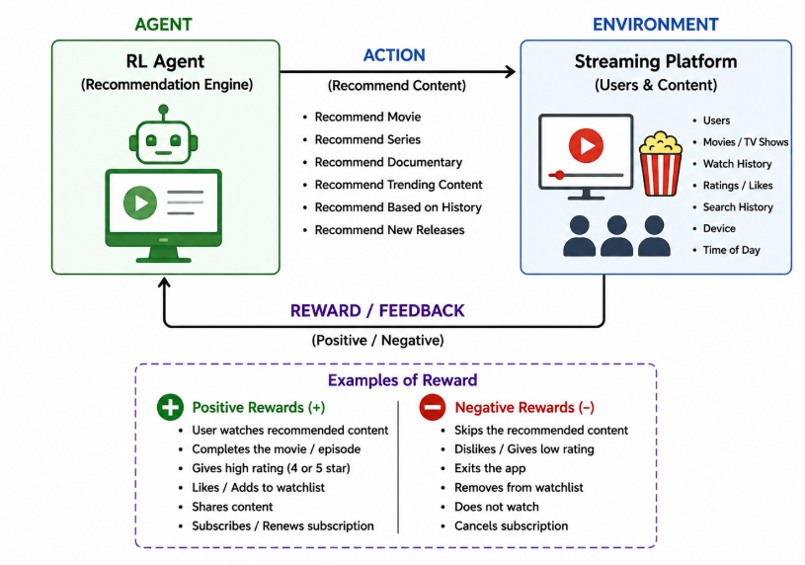
2.14 Real-World Industry Example
Popular streaming platforms use recommendation systems powered by AI and machine learning, such as:
- Netflix
- YouTube
- Amazon Prime Video
These platforms continuously learn from user interactions to personalize content recommendations and improve user experience.

2.15 Advantages
- Personalized recommendations.
- Higher user satisfaction.
- Increased watch time.
- Improves recommendation accuracy.
- Supports long-term user engagement.

2.16 Expected Outcome
By applying Reinforcement Learning, the streaming platform continuously learns from user interactions and feedback to recommend relevant content. Over time, the recommendation engine adapts to changing user preferences, increases watch time, enhances user satisfaction, and improves customer retention. This results in a highly personalized and engaging streaming experience.
Conclusion
Reinforcement Learning is an effective approach for streaming platform recommendations because it continuously learns from user behavior, delayed rewards, and changing preferences. By defining suitable states, actions, rewards, and policies, the RL agent delivers personalized recommendations that improve user engagement and platform performance over time.

3. Analyse how Reinforcement Learning can be used to optimize transportation systems such as bus scheduling or route allocation. Define states, actions, and rewards, and discuss how real-time data improves performance.
Reinforcement Learning for Transportation System (Bus Scheduling)
3.1 Objective
The objective is to develop an intelligent bus scheduling and route allocation system using Reinforcement Learning (RL). The system learns the best schedules and routes to minimize passenger waiting time, reduce fuel consumption, avoid traffic congestion, and improve the efficiency of public transportation.
3.2 Why Reinforcement Learning is Suitable
Traditional bus scheduling uses fixed timetables that cannot adapt to changing traffic conditions or passenger demand. Reinforcement Learning continuously learns from real-time data and improves scheduling decisions automatically.RL is suitable because it:
- Adapts to changing traffic conditions.
- Optimizes bus schedules dynamically.
- Reduces passenger waiting time.
- Improves fuel efficiency.
- Maximizes bus utilization.
- Continuously improves performance through experience.
3.3 Agent and Environment
Agent- The Bus Scheduling System (or Smart Transport Controller) acts as the RL agent.
Environment- The environment includes:
- Bus routes and stops
- Passenger demand
- Traffic conditions and Weather conditions
- Road network
- GPS location
- Time of day
The agent observes the transportation environment, selects schedules or routes, receives rewards, and learns from experience.
3.4 State Space
The state represents the current condition of the transportation system.
Examples include:
- Current bus location
- Number of waiting passengers
- Traffic congestion level
- Bus occupancy
- Fuel level
- Time of day
- Weather condition
Example State: S = {Bus = Route 12, Traffic = Heavy, Passengers = 35, Time = 8:30 AM}
3.5 Action Space
The actions are the decisions taken by the RL agent.
Possible actions:
- Dispatch a bus
- Delay departure
- Change bus route
- Allocate extra bus
- Skip low-demand stop
- Increase service frequency
- Reduce service frequency
- Select alternate route
- Return bus to depot
3.6 Reward Function
The reward function encourages efficient transportation.
Positive Rewards (+)
Action | Reward
Bus arrives on time | +100
Reduce passenger waiting time | +80
Avoid traffic congestion | +50
Fuel-efficient route | +40
High passenger satisfaction | +100
Efficient bus utilization | +70
Negative Rewards (−)
Action | Penalty
Bus delay | -80
Traffic congestion | -50
Empty bus operation | -30
Excess fuel consumption | -40
Passenger complaints | -60
Missed stop | -100

3.7 Policy- A policy determines the best scheduling or routing action for each transportation state.
Policy Function: π(s) → a
where:
- π = Policy
- s = Current state
- a = Selected action
Example: If traffic is heavy on the usual route, the policy chooses an alternative route or dispatches an additional bus.

3.8 Learning Process
The RL agent improves scheduling through continuous interaction with the transportation system.
Step 1: Observe transportation state.
Step 2: Select scheduling or routing action.
Step 3: Bus operates in the environment.
Step 4: Receive reward or penalty.
Step 5: Update policy.
Step 6: Repeat for future schedules.
- Exploration
The system tries new routes or scheduling strategies to discover better solutions.
Example: Testing a different route during peak hours to reduce travel time.
Advantages:
- Finds shorter routes.
- Learns traffic patterns.
- Improves scheduling decisions.
- Exploitation
The system uses the best-performing schedules and routes learned from previous experience.
Advantages:
- Reliable service.
- Faster travel.
- Lower operating costs.
- Higher passenger satisfaction.

3.9 Real-Time Data
Real-time information greatly improves transportation performance.
The RL system continuously receives:
- Live traffic updates
- GPS location of buses
- Passenger count
- Weather information
- Road closures
- Accident reports
- Peak-hour demand
Using this data, the agent dynamically adjusts schedules and routes, resulting in better service and fewer delays.

3.10 Continuous Learning
Continuous learning enables the RL agent to:
- Learn from every trip.
- Predict traffic congestion.
- Improve scheduling accuracy.
- Adapt to changing passenger demand.
- Reduce delays.
- Increase operational efficiency.
The more operational data collected, the better the scheduling decisions become over time.

3.11 RL Architecture
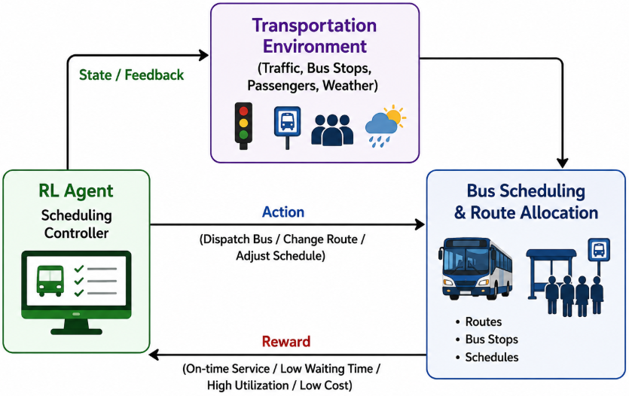
3.12 Real-World Industry Example
Many cities use AI-based transportation systems to improve bus scheduling and route planning, including:
- Transport for London (TfL) – Uses real-time data for scheduling and congestion management.
- Singapore Smart Mobility – Optimizes public transport using AI and live traffic information.
- BMTC (Bengaluru) – Uses GPS-based tracking to improve bus operations.
- MTC Chennai – Increasingly uses GPS and digital monitoring for bus management.
These systems help reduce delays, improve passenger satisfaction, and optimize public transport services.

3.13 Advantages
- Reduces passenger waiting time.
- Optimizes bus schedules.
- Improves fuel efficiency.
- Reduces traffic congestion.
- Adapts to real-time traffic.
- Increases bus utilization.
- Improves passenger satisfaction.
- Continuously learns and improves.

3.14 Expected Outcome
By applying Reinforcement Learning, the transportation system continuously learns the most efficient bus schedules and routes using real-time traffic and passenger data. The RL agent minimizes delays, reduces operational costs, improves resource utilization, and enhances passenger satisfaction. Over time, the system becomes more intelligent, adaptive, and efficient in managing public transportation.

Conclusion
Reinforcement Learning provides an intelligent solution for bus scheduling and route allocation by enabling transportation systems to learn from experience and adapt to changing traffic and passenger conditions. Through appropriate states, actions, rewards, and policies, the RL agent continuously improves decision-making, resulting in reliable, cost-effective, and efficient public transportation services.

4. Apply Reinforcement Learning to dynamic pricing in e-commerce. Define the state space, action space, and reward function. Discuss challenges in balancing exploration and exploitation.
Ans: Reinforcement Learning for Dynamic Pricing in E-commerce
4.1 Objective
The objective is to develop an intelligent dynamic pricing system using Reinforcement Learning (RL) that automatically adjusts product prices based on customer demand, competitor pricing, inventory levels, and market trends. The system aims to maximize revenue, increase sales, and improve customer satisfaction.
4.2 Why Reinforcement Learning is Suitable
Traditional pricing methods use fixed rules and manual updates, which cannot respond quickly to changing market conditions. Reinforcement Learning continuously learns from customer behavior and market data to determine the best price for each product.
RL is suitable because it:
- Adapts to changing market demand.
- Maximizes profit and revenue.
- Learns customer purchasing behavior.
- Optimizes prices in real time.
- Continuously improves pricing strategies.
4.3 Agent and Environment
Agent: The Dynamic Pricing System acts as the RL agent.
Environment: The environment includes:
- Customers
- Product inventory
- Competitor prices
- Market demand
- Seasonal trends
- Customer purchasing behavior
- Sales history
- Promotions and discounts
4.4 State Space
The state represents the current market condition.
Examples include:
- Current product price
- Customer demand
- Inventory level
- Competitor price
- Time of day
- Season
- Product popularity
- Sales trend
Example State
S = {Price = ₹1200, Demand = High, Inventory = 50 units, Competitor Price = ₹1250}
4.5 Action Space
The actions are the pricing decisions made by the RL agent.
Possible actions:
- Increase price by 5%
- Increase price by 10%
- Reduce price by 5%
- Reduce price by 10%
- Maintain current price
- Offer discount
- Launch promotional offer
- Bundle products

4.6 Reward Function
The reward function measures how effective the pricing decision is.
Positive Rewards (+)
Action | Reward
Increase sales | +100
Higher profit | +120
High customer satisfaction | +60
Inventory sold efficiently | +80
Revenue increases | +150

Negative Rewards (−)
Action | Penalty
Sales decrease | -80
Low customer demand | -60
Overstock inventory | -50
Customer dissatisfaction | -70
Revenue loss | -100
The RL agent aims to maximize total rewards while minimizing penalties.

4.7 Policy
A policy determines the best pricing decision for every market state.
Policy Function: π(s) → a
where:
- π = Policy
- s = Current state
- a = Pricing action
Example: If customer demand is high and inventory is limited, the policy may slightly increase the product price to maximize profit.

4.8 Learning Process
The RL agent continuously learns through customer interactions.
Step 1: Observe market conditions.
Step 2: Select a pricing action.
Step 3: Customers respond by purchasing or ignoring the product.
Step 4: Receive reward or penalty.
Step 5: Update pricing policy.
Step 6: Repeat continuously.

4.9 Exploration and Exploitation
- Exploration
The RL agent experiments with new pricing strategies to discover better pricing options.
Examples: Offering a new discount.
Advantages
- Finds better pricing strategies.
- Learns customer preferences.
- Adapts to changing market trends.
- Exploitation
The RL agent uses the best-performing pricing strategy learned from previous experience.
Examples: Using the price that generated the highest sales.
Advantages
- Maximizes profit.
- Increases revenue.
- Improves pricing efficiency.

4.10 Challenges in Balancing Exploration and Exploitation
Balancing exploration and exploitation is one of the biggest challenges in RL.
Exploration Challenges
- Temporary revenue loss.
- Customer dissatisfaction if prices fluctuate frequently.
- Risk of choosing ineffective pricing strategies.
Exploitation Challenges
- Missing better pricing opportunities.
- Difficulty adapting to changing customer preferences.
- Reduced competitiveness in dynamic markets.

4.11 Continuous Learning
Continuous learning enables the RL system to:
- Learn customer buying behavior.
- Adjust prices in real time.
- Respond to competitor price changes.
- Improve demand forecasting.
- Maximize long-term revenue.
- Optimize inventory management.
4.12 RL Architecture
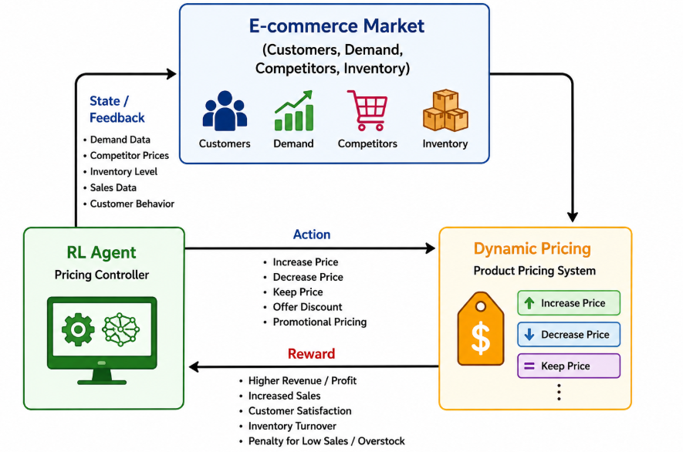
13. Real-World Industry Example
Many e-commerce companies use AI-based dynamic pricing systems, such as:
- Amazon
- Flipkart
- Walmart
- Myntra
- Alibaba
These companies automatically adjust product prices based on demand, competitor pricing, inventory levels, and customer purchasing behavior to maximize revenue and improve competitiveness.

14. Advantages
- Maximizes revenue.
- Improves profit margins.
- Responds to market changes instantly.
- Optimizes inventory utilization.
- Learns customer behavior.
- Adapts to competitor pricing.
4.15 Expected Outcome
By applying Reinforcement Learning, the e-commerce platform continuously learns the best pricing strategies based on customer demand, competitor prices, and inventory levels. The RL agent maximizes revenue, improves customer satisfaction, and adapts to changing market conditions. Over time, the pricing system becomes more intelligent, efficient, and profitable.
Conclusion
Reinforcement Learning is an effective solution for dynamic pricing in e-commerce because it enables systems to learn optimal pricing strategies through continuous interaction with the market. By defining appropriate states, actions, rewards, and policies, the RL agent improves pricing decisions, maximizes long-term revenue, and adapts to changing customer behavior and market conditions.

5. Illustrate the use of Reinforcement Learning in smart city waste management systems. Identify the MDP components and discuss how continuous updates improve operational efficiency.
Ans: Reinforcement Learning for Smart City Waste Management
5.1 Objective
The objective is to develop an intelligent waste management system using Reinforcement Learning (RL) that optimizes waste collection routes, schedules garbage collection efficiently, reduces operational costs, and maintains a clean city environment.

5.2 Why Reinforcement Learning is Suitable
Traditional waste collection follows fixed schedules, which may result in overflowing bins or unnecessary trips. Reinforcement Learning continuously learns from sensor data and city conditions to improve waste collection decisions.
RL is suitable because it:
- Optimizes garbage collection routes.
- Reduces fuel consumption.
- Prevents overflowing bins.
- Minimizes operational costs.
- Continuously adapts to changing waste levels.

5.3 Agent and Environment
Agent- The Smart Waste Collection Controller acts as the RL agent.
Environment- The environment includes:
- Smart waste bins
- Garbage trucks
- City roads
- Traffic conditions
- Waste level sensors
- Weather conditions
- Collection schedules
The RL agent observes the environment, decides which bins to collect, receives rewards, and continuously improves its strategy.

5.4 MDP Components
State Space (S)- The state represents the current condition of the waste management system.
Examples:
- Waste bin fill level
- Truck location
- Traffic congestion
- Fuel level
- Weather condition
- Time of day
- Number of bins waiting for collection
Example State:
S = {Bin = 90% Full, Truck = Zone A, Traffic = Low, Weather = Sunny}

Action Space (A)
Possible actions include:
- Collect waste from a bin
- Skip low-fill bin
- Send garbage truck
- Change collection route
- Assign another truck
- Return to depot
- Delay collection
- Choose shortest route

Reward Function (R)-
Positive Rewards (+)
Action | Reward
Collect full bin | +100
Reduce travel distance | +50
Save fuel | +40
Complete route efficiently | +80
Prevent overflowing bins | +120

Negative Rewards (−)
Action | Penalty
Overflowing waste bin | -100
Unnecessary collection | -40
Traffic delay | -30
High fuel consumption | -50
Missed collection | -80

Policy (π)
The policy determines the best action for each state.
π(s) → a
Example: If a waste bin is almost full and traffic is low, the policy dispatches the nearest garbage truck immediately.

5.5. Learning Process
The RL agent follows these steps:
Step 1: Observe the current state.
Step 2: Choose the best action.
Step 3: Collect waste or update the route.
Step 4: Receive reward or penalty.
Step 5: Update the policy.
Step 6: Repeat continuously.

- Exploration
The system tries new collection routes and schedules to identify more efficient waste collection strategies.
Advantages
- Finds shorter routes.
- Learns changing waste generation patterns.
- Improves route optimization.

- Exploitation
The system uses the best-performing routes and schedules learned from previous experience.
Advantages
- Reduces fuel consumption.
- Improves collection efficiency.
- Minimizes operational costs.

5.6 Continuous Updates
Continuous updates help the RL agent improve operational efficiency by learning from real-time information such as:
- Smart bin sensor data
- Traffic conditions
- GPS location of trucks
- Weather updates
- Daily waste generation
- Road closures
As more operational data is collected, the RL system continuously updates its policy, making waste collection faster, more reliable, and cost-effective.

7. RL Architecture
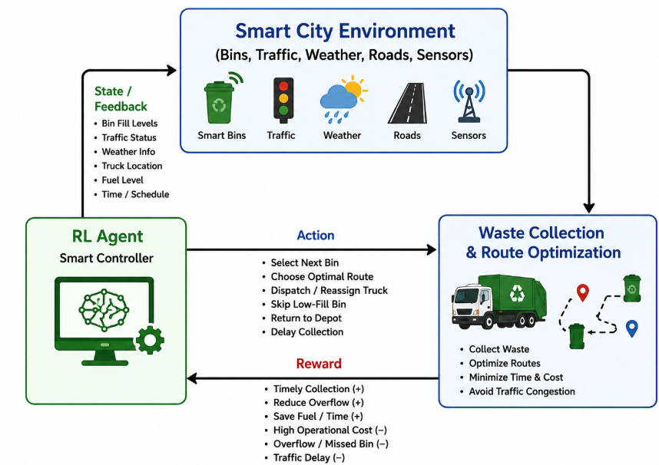

5.8 Real-World Industry Example
Several smart cities use AI and IoT-based waste management systems:
- Singapore Smart Nation – Uses smart sensors and AI for waste collection.
- Barcelona Smart City – Optimizes garbage collection using sensor-enabled bins.
- Seoul Smart City – Uses intelligent waste management systems.
- Indore Smart City (India) – Uses GPS-enabled waste collection vehicles and smart monitoring.
These systems improve cleanliness, reduce fuel consumption, and optimize waste collection operations.
5.9 Advantages
- Optimizes garbage collection routes.
- Prevents overflowing bins.
- Reduces fuel consumption.
- Minimizes operational costs.
- Adapts to changing waste levels.
- Improves city cleanliness.
- Supports smart city initiatives.
- Continuously learns and improves.

5.10 Expected Outcome
By applying Reinforcement Learning, the smart city waste management system continuously learns the best collection schedules and routes based on real-time sensor data and environmental conditions. The RL agent reduces operational costs, prevents overflowing bins, improves route efficiency, and enhances the cleanliness of the city. Over time, the system becomes more intelligent, adaptive, and efficient.

Conclusion
Reinforcement Learning provides an intelligent solution for smart city waste management by enabling automated route optimization and efficient garbage collection. Through well-defined MDP components, continuous learning, and real-time updates, the RL agent improves decision-making, reduces costs, and enhances urban cleanliness, making it an ideal approach for modern smart city applications.

Code of Conduct:

I R. Rupa Sree (192472122) (Name / Reg No) certify that this submission is my original work and that I have adhered to the guidelines specified for this assessment.
I understand that any violation of academic integrity rules will result in disciplinary action.

Signature of the student: R. Rupa Sree

RUBRICS FOR CALCULATION

Criteria | Weightage | Level 4 – Exemplary | Level 3 – Proficient | Level 2 – Developing | Level 1 – Beginning
Understanding of Industry Problem | 20% | Comprehensive understanding of real-world problem and constraints | Good understanding with minor gaps in requirements | Basic understanding; some requirements unclear | Poor understanding; misinterprets problem context
Application of Engineering Concepts | 25% | Applies advanced and relevant concepts effectively to solve the problem | Applies appropriate concepts with minor errors | Limited application of concepts | Incorrect or no application of concepts
Solution Design | 25% | Innovative, practical, and feasible solution aligned with industry standards | Logical and feasible solution with minor gaps | Basic solution with limited feasibility | Unclear or impractical solution
Use of Tools | 15% | Effective use of modern tools, technologies, and real data | Appropriate use of tools with correct implementation | Limited or inconsistent use of tools | Minimal or incorrect use of tools
Analysis | 10% | Thorough analysis with validated results and performance evaluation | Good analysis with reasonable validation | Basic analysis with limited validation | Poor or no analysis
Professionalism | 5% | Highly professional, well-documented, and clearly presented work | Good documentation and presentation | Basic documentation with some gaps | Poor documentation and presentation

